SIMATS ENGINEERING (SAVEETHA SCHOOL OF ENGINEERING)
Department of Computer Science and Engineering
ASSESSMENT TOOL 3 – DEBUGGING & OPTIMISATION TASK
Course Code: | CSA06 | Course Title: | Design and Analysis of Algorithms
CO Assessed: | CO2 – Manipulation (BL1, BL2, BL3) | Assessment: | Assessment Tool 3 – Debugging & Optimisation Task
Weightage: | 10% of CIA | Total Marks: | 100
CO2 Statement: | Apply Brute Force technique to solve sorting, searching, Closest-Pair and Convex-Hull problems (BL1, BL2, BL3)
Student Name: | M. Niharika | Reg. No.: | 192472392
Section / Batch: | CSE-AI | Date: | 23-07-26

Instructions to Students
• Answer ALL debugging and optimisation tasks. Total Marks: 100.
• Carefully analyze the given program/code segment before identifying errors.
• Clearly identify logical, syntactical, and performance-related issues in the code.
• Apply systematic debugging techniques to correct the errors effectively.
• Optimize the given solution by improving efficiency, reducing unnecessary computations, or enhancing time complexity wherever possible.
• Provide proper justification for all corrections and optimization decisions.
• Write clean, structured, and well-documented code with appropriate comments.
• Maintain clarity, logical reasoning, and technical accuracy throughout the solution.

Question Type | Focus Area | Questions | Marks
Debugging & Optimisation Task | Identify errors, debug programs, and optimize algorithm efficiency using appropriate techniques | Q1 - Q2 | 100 (2 × 50)
GRAND TOTAL: |  | 100 Marks

SECTION A – DEBUGGING & OPTIMISATION TASK

Code of Conduct
I __________________________ (Name / Reg No) certify that this submission is my original work and that I have adhered to the guidelines specified for this assessment. I understand that any violation of academic integrity rules will result in disciplinary action.
Signature of the Student: _________________________
RUBRICS FOR CALCULATION
Criteria | Wt. | Level 4 – Exemplary | Level 3 – Proficient | Level 2 – Developing | Level 1 – Beginning
Problem Identification | 20% | Accurately identifies all errors and root causes with clear understanding | Identifies most errors with minor gaps | Identifies some errors but misses key issues | Unable to identify errors correctly
Debugging | 25% | Applies systematic debugging techniques effectively to resolve issues | Uses appropriate debugging methods with minor errors | Limited debugging approach; requires guidance | Unable to debug or resolve issues
Optimization | 20% | Optimizes code by significantly improving time complexity using efficient algorithms | Improves time complexity with minor gaps in efficiency | Limited improvement in time complexity | No improvement; inefficient approach retained
Analysis | 20% | Demonstrates strong logical reasoning and clear justification of solutions | Shows reasonable analysis with some justification | Limited analysis; weak reasoning | No analytical reasoning demonstrated
Code Quality | 15% | Produces clean, well-structured code with proper comments and documentation | Code is mostly clear with minor documentation gaps | Code lacks structure and proper documentation | Poorly written code with no documentation

Marks Evaluation:
Question No. | Problem Identification (20%) | Debugging (25%) | Optimization (20%) | Analysis (20%) | Code Quality (15%) | Total Marks (Each – 50)
Q1
Q2
Overall Total (100)

Faculty In-charge | Course Coordinator | Head of Department
Signature: _______________ | Signature: _______________ | Signature: _______________
Date: ___________________ | Date: ___________________ | Date: ___________________

CO2 -AT3: DEBUGGING AND OPTIMIZATION TASK

Q141. Debugging Selection Sort Code (Minimum Index Compared Against Wrong Loop
Variable in C)
The following Selection Sort implementation in C compares the candidate element against
arr[j] instead of arr[min_idx], which prevents the algorithm from preserving the true
minimum seen so far within the current pass. Carefully analyze why the minimum candidate
must be updated relative to the current best position, not the current scanning position. Apply
systematic debugging so that the smallest element of the unsorted region is tracked correctly.
Optimize the corrected implementation by skipping unnecessary swaps when no movement is needed. Analyze the time complexity of the corrected version and rewrite the final optimized
C code with proper comments.
void selectionSort(int arr[], int n) {
int i, j, min_idx, temp;
for (i = 0; i < n - 1; i++) {
min_idx = i;
for (j = i + 1; j < n; j++) {
if (arr[j] < arr[j]) { // ERROR
min_idx = j;
}
}
temp = arr[i];
arr[i] = arr[min_idx];
arr[min_idx] = temp;
}
}
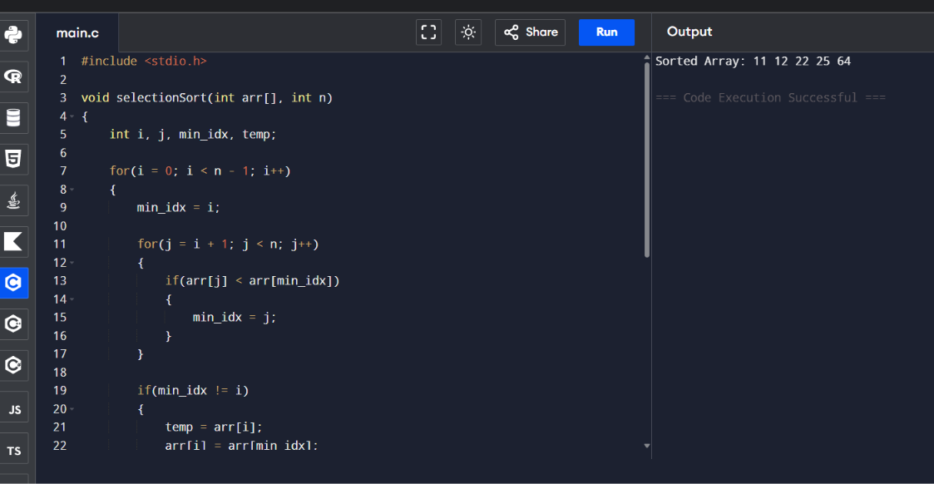
Q142. Debugging Bubble Sort Code (Final Comparison of Each Pass Skipped in C)
The following Bubble Sort implementation in C stops the inner loop too early by using < n
- i - 2, which causes the final adjacent comparison of each pass to be skipped. Carefully
analyze why missing even one adjacent check can leave inversions unresolved and prevent
complete sorting. Apply systematic debugging so that every required adjacent pair in the
unsorted region is examined. Optimize the corrected implementation using a swap flag to
reduce unnecessary passes when the array becomes sorted. Analyze the best, average, and
worst-case complexity and rewrite the final C code with proper comments.
void bubbleSort(int arr[], int n) {
int i, j, temp;
for (i = 0; i < n - 1; i++) {
for (j = 0; j < n - i - 2; j++) { // ERROR
if (arr[j] > arr[j + 1]) {
temp = arr[j];
arr[j] = arr[j + 1];
arr[j + 1] = temp;
}
}
}
}
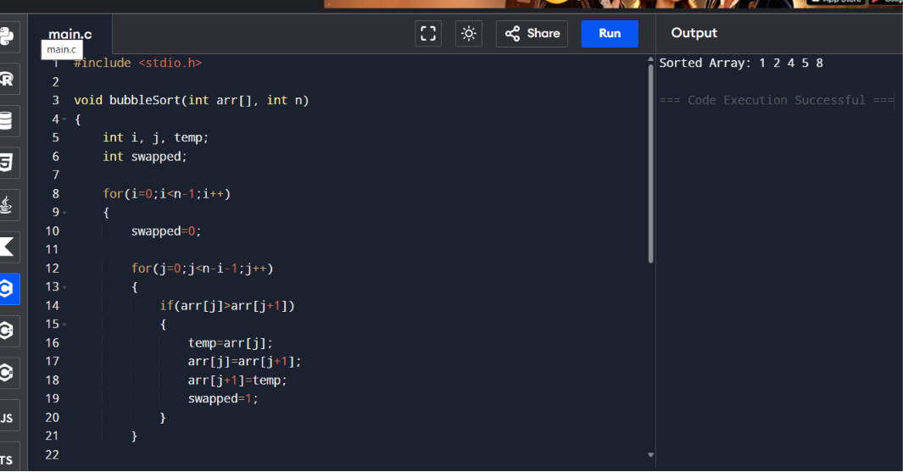
Q143. Debugging Linear Search Code (Returned Value Is Element Instead of Index in
C)
The following Linear Search implementation in C returns the element value when a match is
found instead of returning its array index, which violates the intended specification of the
function. Carefully analyze why the caller cannot identify the position of the key from this
result when duplicates exist. Apply systematic debugging so that the function returns the
correct index for the first matching element. Optimize the corrected implementation for
simple and maintainable behavior. Analyze the time complexity of the corrected solution and
rewrite the final C code with suitable comments.
int linearSearch(int arr[], int n, int key) {
int i;
for (i = 0; i < n; i++) {
if (arr[i] == key)
return arr[i]; // ERROR
}
return -1;
}
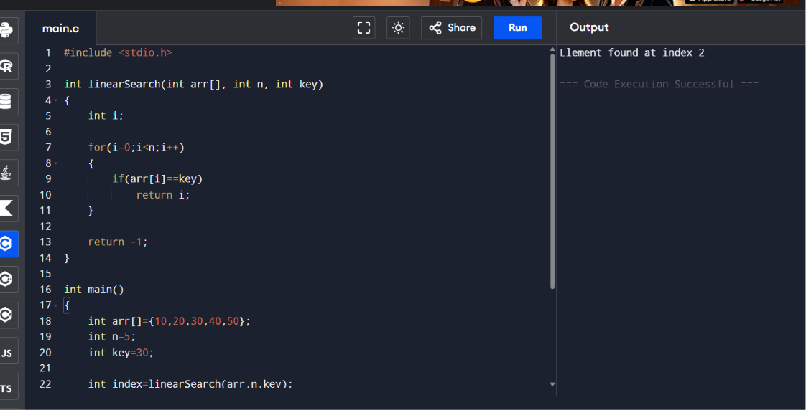
Q144. Debugging Binary Search Code (Unsorted Input Assumption Not Checked in C)
The following Binary Search implementation in C assumes that the input array is sorted, but
it is being called on arbitrary arrays without validation or preparation, which can produce
meaningless results. Carefully analyze why Binary Search depends completely on ordered
data and how this assumption affects correctness. Apply debugging by redesigning the usage
logic so that either the input is guaranteed sorted or an appropriate preprocessing step is
performed before search. Optimize the corrected approach by clearly documenting the
precondition and handling edge cases safely. Analyze the best, average, and worst-case
complexity of the corrected searching strategy and rewrite the final C code with proper
comments.
int binarySearch(int arr[], int n, int key) {
int low = 0, high = n - 1, mid;
while (low <= high) {
mid = (low + high) / 2;
if (arr[mid] == key)
return mid;
else if (arr[mid] < key)
low = mid + 1;
else
high = mid - 1;
}
return -1;
}
/* Called on unsorted arrays */
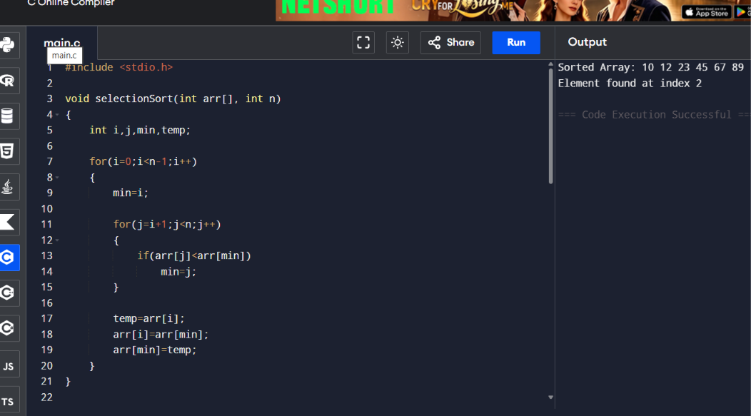
Q145. Debugging Closest Pair Code (Minimum Distance Returned Uninitialized for
Small Input in C)
The following brute force Closest Pair implementation in C does not handle the case where
the number of points is less than two, so the minimum-distance variable may be returned
without a meaningful pair comparison. Carefully analyze why small-input validation is
required before entering pairwise computation. Apply systematic debugging so that the
function safely handles invalid or insufficient input sizes and returns an appropriate indicator.
Optimize the corrected implementation for robustness and clear documentation of
assumptions. Analyze the time complexity of the corrected solution and rewrite the final C
code with proper comments.
#include <math.h>
double closestPair(int x[], int y[], int n) {
int i, j;
double minDist = 1e9;
for (i = 0; i < n; i++) {
for (j = i + 1; j < n; j++) {
double dist = sqrt((x[i] - x[j]) * (x[i] - x[j]) +
(y[i] - y[j]) * (y[i] - y[j]));
if (dist < minDist)
minDist = dist;
}
}
return minDist; /* ISSUE when n < 2 */
}
